

**LAB-03**

**Title: Use of Conditional Operator in SQL.**

**Name: Azizul Abedin Azmi**

**ID: 2022-1-60-130**

**Section: 02**

**Course Code: CSE302**

**Course Title: (Database Management System)**

**Date: 16/07/2024**

**Course Instructor:**

**Dr. Mohammad Arifuzzaman**

**Associate Professor**

**Department of Computer Science and Engineering**

**Task-1:**

CREATE TABLE Loan (

    Loan_no INT PRIMARY KEY,

    Amount INT,

    Branch_name VARCHAR(50)

);

-- Inserting data into Loan table

INSERT INTO Loan (Loan_no, Amount, Branch_name)

VALUES

    (245, 12000, 'Banani'),

    (310, 15000, 'Gulshan'),

    (350, 10000, 'Gulshan'),

    (450, 8000, 'Uttara');

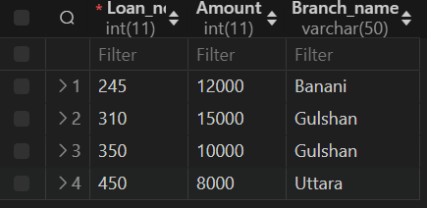

CREATE TABLE Account (

    Acct_no INT PRIMARY KEY,

    Balance INT,

    Branch_name VARCHAR(50)

);

INSERT INTO Account (Acct_no, Balance, Branch_name)

VALUES

    (101, 20000, 'Gulshan'),

    (203, 50000, 'Uttara'),

    (306, 30000, 'Banani');

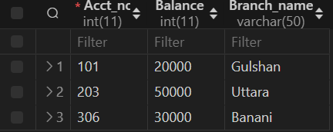

**Task-2:**

select loan_no from loan where amount=(select MIN(amount) from loan)



**Task-3:**

select MAX(balance) as max_balance from account



**Task-4:**

select branch_name from account where balance=(select MAX(balance) from account)



**Task-5:**

select AVG(amount) as avg_amount from loan



**Task-6:**

select COUNT(acct_no) as No_of_acc from account



**Exercise-1:**

CREATE TABLE Employee_details (

    EmpId INT PRIMARY KEY,

    EmpName VARCHAR(50),

    ProjectName VARCHAR(50),

    Salary INT

);

INSERT INTO Employee_details (EmpId, EmpName, ProjectName, Salary)

VALUES

    (602, 'Asif', 'CloudService', 15000),

    (925, 'Bob', 'CloudService', 13000),

    (564, 'Charlie', 'ITDevelop', 17000),

    (345, 'Suzan', 'CloudService', 10000),

    (276, 'Alex', 'ITDevelop', 8000);

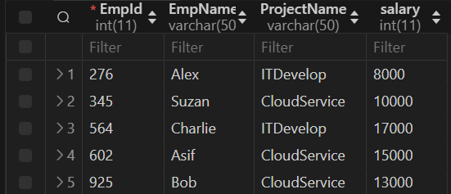

**Exercise-2:**

select MAX(EmpId) as max_EmpId from employee_details



**Exercise-3:**

select MIN(salary) as min_salary from employee_details



**Exercise-4:**

select MAx(salary) as max_salary from employee_details



**Exercise-5:**

select AVG(salary) as avg_salary from employee_details



**Exercise-6:**

select COUNT(EmpId) as No_of_emplo from Employee_details



**Exercise-7:**

select MAX(salary) as max_salary from employee_details where ProjectName='CloudService'



**Exercise-8:**

select MIN(salary) as min_salary from employee_details where ProjectName='ITDevelop'



**Exercise-9:**

select AVG(salary) as avg_salary from employee_details where ProjectName ='ITDevelop'



**Exercise-10:**

select EmpName from employee_details where salary=(select MAX(salary) from employee_details)



**Exercise-11:**

select EmpName from employee_details where salary > (select AVG(salary) from employee_details)

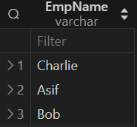

**Exercise-12:**

select EmpName from employee_details where EmpId = (select MIN(EmpId) from employee_details)



**Exercise-13:**

select SUM(salary) as tol_expense from employee_details where ProjectName ='ITDevelop'



**Exercise-14:**

select AVG(salary) as avg_salary from employee_details where ProjectName ='CloudService'



**Exercise-15:**

select COUNT(*) as No_of_acemplo from employee_details where ProjectName ='CloudService'



**Conclusion:**

From the above information and exercises, we can conclude the following:

* SQL commands such as SELECT, WHERE, IN, BETWEEN, and <> (not equal) were used effectively to retrieve specific data from tables.
* Conditional operators (=, <>, >, <, >=, <=, BETWEEN, IN) were applied to filter records based on specified conditions.
* Tables (Student_info, Course_info, Workers) were created, and data was inserted into them using CREATE TABLE and INSERT INTO statements.
* Each task and exercise provided a hands-on experience with SQL queries to manipulate and extract data as per given requirements.